Phase 3: UI/UX Development & Customization
Interface Design

Description
This phase focuses on designing and customizing user-friendly interfaces in ServiceNow to enhance usability, accessibility, and consistency with business requirements. It includes Service Catalog creation, variable configuration, layout design, and form optimisation using native ServiceNow UI capabilities.

Phase Objective
- Design intuitive Service Catalog interfaces
- Improve user experience through structured forms
- Ensure consistent and business-aligned UI layouts
- Reduce user errors through guided input

Tools Used
- Service Catalog
- Variables & Variable Sets
- UI Policies
- UI Actions
- ServiceNow UI Builder

Activity 1: Creation of Service Catalog Item
Description
This activity involves creating a Service Catalog item that acts as the primary user-facing interface for submitting network-related requests.
Procedure
- Navigate to Application Navigator
- Click All
- Search for Service Catalog
- Navigate to Service Catalog > Maintain Items
- Click New
- Fill in the details:
  - Name: Network Request
  - Catalog: Service Catalog
  - Category: Network
  - Short Description: Network Request Management
- Click Save

Activity 2: Variables Configuration
Description
Variables are used to capture user input through form fields. These variables define the structure and behaviour of the Service Catalog form.

Procedure
- Open the Network Request catalog item
- Scroll down to the Variables related list
- Click New
- Configure the following:
  - Variable Type: Single Line Text / Multi Line Text / Choice / Reference (as required)
  - Catalog Item: Network Request
  - Order: 100, 200, 300, etc.
  - Question: Field label shown to users
  - Name: Internal variable name (used for scripting)
  - Tooltip: Help text shown on hover
  - Example Text: Sample input for guidance
  - Mandatory / Read-Only: Configure as required
  - Auto-populate: Use dependent variable with dot-walking
- Click Save or Submit.
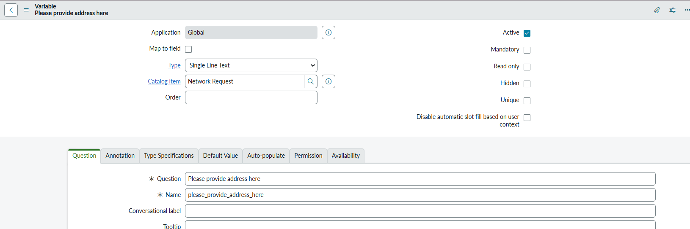

Activity 3: Variable Types Configuration
Description
Different variable types are used to capture specific user inputs effectively.

Question | Variable Type | Options
Is this a new connection or relocation? | Choice | New / Relocation / None
If this is a relocation, provide the relocated address | String | —
Types of devices | Choice | Laptop / Mobile / Others
Provide address here | String | —
Provide device details here | String | —
If anything else, please specify | String | —

Activity 4: Variable Set Configuration
Description
Variable Sets are used to group commonly used fields to improve form reusability and maintain consistency across catalog items.

Procedure
- Navigate to Variable Sets
- Click New
- Follow the same steps used in variable creation
- Add variables to the Variable Set
- Apply the Variable Set to the Network Request catalog item

Variable Set – User Information

Variable | Type | Configuration
Opened on behalf of | Reference | Reference to the User table
Email ID | Single Line Text | Auto-populate from Opened on behalf
User Name | Single Line Text | Auto-populate from Opened on behalf
Phone Number | Single Line Text | Auto-populate from Opened on behalf
Proof of Document | Attachment | File upload enabled

Outcome
- Clean and user-friendly Service Catalog form
- Improved usability and faster request submission
- Standardized UI layout across catalog items
- Reduced dependency on scripting through configuration-based design.
